
SRM Institute of Science and Technology
Mode of Exam
OFFLINE
College of Engineering and Technology
School of Computing
DEPARTMENT OF COMPUTING TECHNOLOGIES
SRM Nagar, Kattankulathur – 603203, Chengalpattu District, Tamilnadu
Academic Year: 2023-2024 (ODD)
Test: CLAT-1 Date: 09-08-2023
Course Code & Title: 18CSE458T – Wireless and Mobile Communication Duration: 50 Minutes
Year & Sem: IV Year – VII Semester Max. Marks: 25

Course Articulation Matrix: (to be placed)

Part - A
( 5 x 1 = 5 Marks)
Instructions: Answer all
Q. No | Question | Marks | BL | CO | PO | PI Code
1 | - 100m | 1 | 1 | 1 | 1 | 1.6.1
2 | d) FSK | 1 | 2 | 1 | 1 | 1.6.1
3 | b) Hopset | 1 | 1 | 1 | 1 | 1.6.1
4 | a)Transmitters | 1 | 2 | 1 | 1 | 1.6.1
5 | a) Bandwidth of input signal | 1 | 1 | 1 | 1 | 1.6.1
Part – B
( 5 x 2 = 10 Marks)
Instructions: Answer all
6 | list the advantages of wireless communications  Freedom from wires: Can be configured with the use of any physical connection.  Easy to setup: Wireless network is easy to expand and setup  Better or global coverage: It provides global reach by providing networking in places such as rural areas, battlefields, etc… where wiring is not feasible.  Flexibility: Wireless network is more flexible and adaptable compared to a wired network.  Cost-effectiveness: Since it is easy to install and doesn’t require cables, the wireless network is relatively cheaper.  Mobile and portable: Wireless network is easy to carry and re-install in another place.  Mobility -: It has good mobility of usage.  Data transmission is fast: In wireless network data transmission is fast.  Low maintenance: In any wireless communication low maintenance cost.  It can be accessed from anywhere and anytime. for ex. professional can complete their work from remote location.  Network planning: Network planning in wireless communication is vey easy as compare to wired network due to wireless software configuration of frequency, power and other parameter.  Expandable: Wireless networks can serve a large number of client without resorting the new hardware. | 2 | 1 | 1 | 1 | 1.6.1
7 | Define Electromagnetic Wave  Electromagnetic, or EM, waves are created from vibrations between electric and magnetic fields. EM waves do not need a medium to propagate, making them ideal for information transfer. For example, electromagnetic waves are used for radios, television, and medical imaging devices in everyday life. | 2 | 1 | 1 | 1 | 1.6.1
8 | Classify Simplex, Half-Duplex and Full-Duplex | 2 | 2 | 1 | 1 | 1.6.1
  Parameters | Simplex Transmission Mode | Half Duplex Transmission Mode | Full Duplex Transmission Mode
  Definition | It is a mode of transmission in which the flow of data is unidirectional. It means that the participant can do only one task at a time in a single direction. The receiver can only receive data and not send it (and vice versa). | It is a mode of transmission in which the flow of data is bi-directional but only in one direction at a time. It means that the receiver can receive as well as send data but can perform only one of these tasks at a time. | It is a mode of transmission in which the flow of data is bi-directional. But here, the devices can send as well as receive data simultaneously at the same time. It means that the receiver can receive as well as send data at the very same time with no hitch.
  Sender and Receiver | The sender can only send data. But there’s no option to receive it (and vice versa). Thus, the transmission involves one station as a sender and the other one as a receiver. | A device can both send and receive data. But it cannot perform both the processes together- only one thing is possible at a time. This mode connects two systems by a point-to-point link for the transmission and receiving of signals. | Both the devices or end stations in the transmission can act as senders as well as receivers. The transmission also occurs simultaneously in both directions at the same time.
  Capacity Usage | The transmission channel’s entire capacity goes into sending the data in just one direction. Thus, this transmission works well when we require the entire bandwidth for data transmission. | It conserves bandwidth and utilizes a single communication channel by sharing it alternatively between both directions. Thus, it works well in the cases where you send data in both directions, but alternatively. | It uses the entire communication channel by splitting it in a way that allows transmission in both directions at the same time. As a result, it works well when we need to communicate in both directions with no delays.
  Performance | The Simplex Mode of transmission is the worst performing one. It is because it takes the longest time to transmit data. | The Half-Duplex Mode, on the other hand, exhibits better performance than the Simplex Mode. But its performance is lower as compared to the Full-Duplex Mode. | The Full-Duplex Mode performs the best among all. It is because the transmission is continual as well as bi-directional. So, there remains no barriers or delay in transmission, plus it doubles the bandwidth utilization.
  Example | The keyboard, Television, Mouse, Radio Broadcasts, and Monitor are great examples of a Simplex transmission. | A Walkie-talkie set is an example of Half Duplex transmission. | Telephone lines, Mobile phones are commendable examples of Full-Duplex transmission.
9 | Classify Modulation and Demodulation in detail | 2 | 2 | 1 | 1 | 1.6.1
  Modulation | Demodulation
  Data is collected and modified onto the carrier. | Data is recovered.
  Modulation is carried out on the sender’s side. | Demodulation takes place on the receiver’s side.
  Modulation is a process in which the original message signal is mixed with a carrier wave whose parameters need to be altered. | Demodulation takes place in order to create an original information signal by separating the carrier signal from the message signal.
  Modulation is done to transmit data over longer distances. | Demodulation is the process that prevents the signal from being modified.
10 | Give example for Frequency Division Multiplexing  The following diagram conceptually represents multiplexing using FDM. It has 4 frequency bands, each of which can carry signal from 1 sender to 1 receiver. Each of the 4 senders is allocated a frequency band. The four frequency bands are multiplexed and sent via the communication channel. At the receiving end, a demultiplexer regenerates the original four signals as outputs.  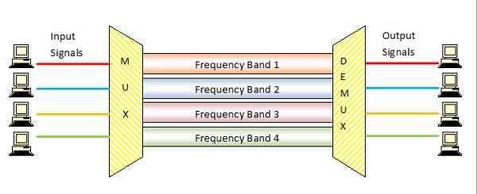  Here, if the frequency bands are of 150 KHz bandwidth separated by 10KHz guard bands, then the capacity of the communication channel should be at least 630 KHz (channels : 150 × 4 + guard bands : 10 × 3). | 2 | 2 | 1 | 1 | 1.6.1
Part – B
( 1 x 10 = 10 Marks)
Instructions: Answer any one
11 a  11 b | Illustrate Amplitude Shift Keying, Frequency Shift Keying and Phase Shift Keying in detail with neat sketch  Amplitude Shift Keying  The amplitude of the resultant output depends upon the input data whether it should be a zero level or a variation of positive and negative, depending upon the carrier frequency.  Amplitude Shift Keying (ASK) is a type of Amplitude Modulation which represents the binary data in the form of variations in the amplitude of a signal.  Following is the diagram for ASK modulated waveform along with its input.  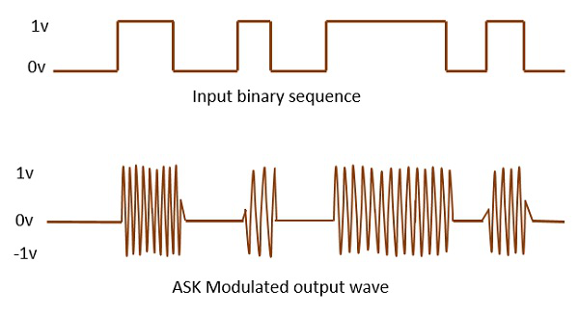  Any modulated signal has a high frequency carrier. The binary signal when ASK is modulated, gives a zero value for LOW input and gives the carrier output for HIGH input.  Frequency Shift Keying  The frequency of the output signal will be either high or low, depending upon the input data applied.  Frequency Shift Keying (FSK) is the digital modulation technique in which the frequency of the carrier signal varies according to the discrete digital changes. FSK is a scheme of frequency modulation.  Following is the diagram for FSK modulated waveform along with its input.  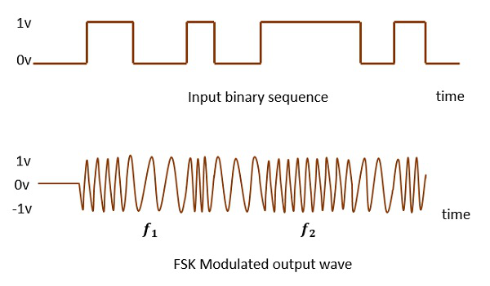  The output of a FSK modulated wave is high in frequency for a binary HIGH input and is low in frequency for a binary LOW input. The binary 1s and 0s are called Mark and Space frequencies.  Phase Shift Keying  The phase of the output signal gets shifted depending upon the input. These are mainly of two types, namely BPSK and QPSK, according to the number of phase shifts. The other one is DPSK which changes the phase according to the previous value.  Phase Shift Keying (PSK) is the digital modulation technique in which the phase of the carrier signal is changed by varying the sine and cosine inputs at a particular time. PSK technique is widely used for wireless LANs, bio-metric, contactless operations, along with RFID and Bluetooth communications.  PSK is of two types, depending upon the phases the signal gets shifted. They are −  Binary Phase Shift Keying (BPSK)  This is also called as 2-phase PSK (or) Phase Reversal Keying. In this technique, the sine wave carrier takes two phase reversals such as 0° and 180°.  BPSK is basically a DSB-SC (Double Sideband Suppressed Carrier) modulation scheme, for message being the digital information.  Following is the image of BPSK Modulated output wave along with its input.  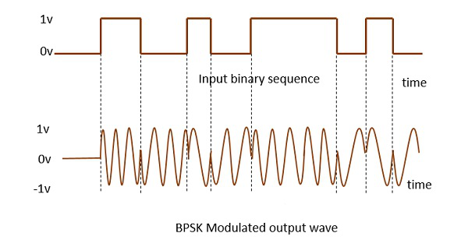  Quadrature Phase Shift Keying (QPSK)  This is the phase shift keying technique, in which the sine wave carrier takes four phase reversals such as 0°, 90°, 180°, and 270°.  If this kind of techniques are further extended, PSK can be done by eight or sixteen values also, depending upon the requirement. The following figure represents the QPSK waveform for two bits input, which shows the modulated result for different instances of binary inputs.  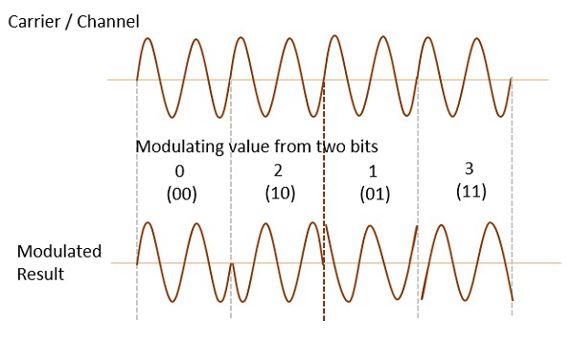  QPSK is a variation of BPSK, and it is also a DSB-SC (Double Sideband Suppressed Carrier) modulation scheme, which send two bits of digital information at a time, called as bigits.  Instead of the conversion of digital bits into a series of digital stream, it converts them into bit-pairs. This decreases the data bit rate to half, which allows space for the other users.  (or)  Explain Frequency Hopping Spread Spectrum and Direct Sequence Spread Spectrum with neat Diagram  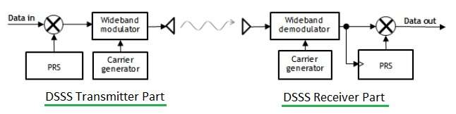  In DSSS, which stands for Direct Sequence Spread Spectrum, information bits are modulated by PN codes(chips). PN codes are Pseudonoise code symbols. This PN codes have short duration compare to information bits. Here transmitted information over the air occupies more bandwidth compare to user informaion bits. DSSS is the modulation technique adopted in IEEE 802.11 based WLAN compliant products. In DSSS systems entire system bandwidth is available for each user all the time.  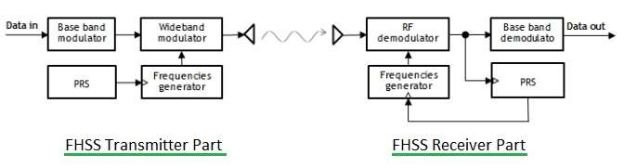  In FHSS, which stands for Frequency Hopping Spread Spectrum, RF carrier frequency is changed according to the Pseudo-random sequence(PRS or PN sequence). This PN sequence is known to both transmitter and Receiver and hence help demodulate/decode the information. Within one chip duration, RF frequency does not vary. Based on this fact there are two types of FHSS, fast hopped FHSS and slow hopped FHSS.  Advantages of FHSS:  Some of the major advantages are as follows:  The processing gain PG is higher than that of DSSS system.  The synchronization is not greatly dependent on the distance.  The serial search system with FHSS needs shorter time for acquisition.  Issues Related to Frequency-Hopping Spread Spectrum in Wireless Networks:  Frequency-hopping spread spectrum uses complex mathematical formulas that change over time and simultaneously change at both sender and receiver sides. The complexity of calculating the formula using a processor or microprocessor is hard to understand.  The accuracy of the frequency hopping spread spectrum is too high (complexity) for some real-world scenarios such as military communication because the number of different sequences available is limited by the memory and computational power at both sender and receiver sides, which restricts its flexibility in assigning certain slots to certain users.  Frequency-hopping spread spectrum is too complex for some real-world scenarios, because it may cause interference between some channels, causing a clash and lack of mutual understanding among users.  The performance of the frequency hopping spread spectrum can be influenced by temperature (temperature affects the speed of frequency changing); it may also be affected by interference between channels. | 10 | 2 | 1 | 1 | 1.6.1

*Performance Indicators are available separately for Computer Science and Engineering in AICTE examination reforms policy.

Course Outcome (CO) and Bloom’s level (BL) Coverage in Questions

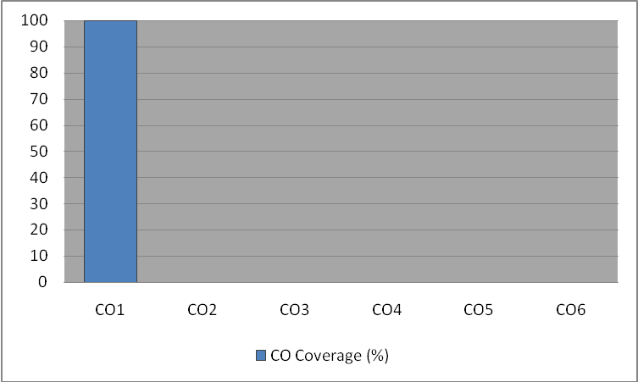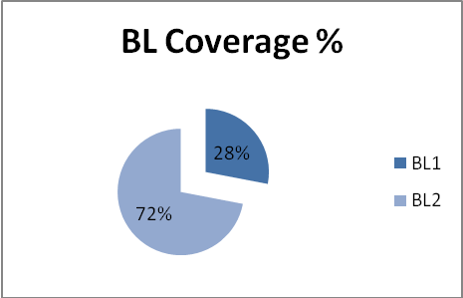

Approved by the Audit Professor/Course Coordinator

